Alarm system to high
Temperature
Assignment -2

BY P.MARITHURAICHI
952319104028

BUILD A PYTHON CODE,ASSUME U GET TEMPERATURE AND HUMIDITY VALUE AND WRITE A CONDITION TO CONTINUOUSLY DETECT ALARM IN CASE IGH TEMPERATURE:

This article, we’ll discuss interacting DHT11 with Raspberry Pi and see it working using Python code. Also, we’ll display real-time Data on the 16×2 LCD. The code and explanation used in the code will be explained further below also all the modules regarding 16×2 LCD will be included with its article home page. So let’s begin.
DHT-11

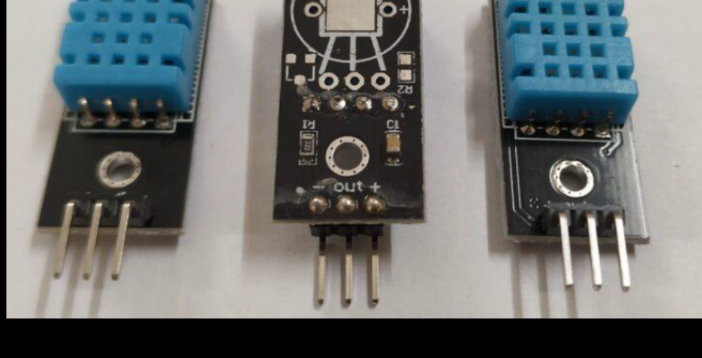

- • It is the most common and famous temperature and humidity combined sensor you’ll ever come to know. It has many tutorials with boards similar to Arduino.

- • You may visit It’s Arduino Tutorial to have a more clear Idea of Its working if you are

working so, here we are giving you thetutorial on how to connect dht11 with Raspberry Pi.
- • DHT11 is a simple sensor and has a very simple structure for measuring temperature and humidity. Basically, it is an enclosed structure that consists of two wires which are responsible for checking humidity and temperature.

Material Requirement

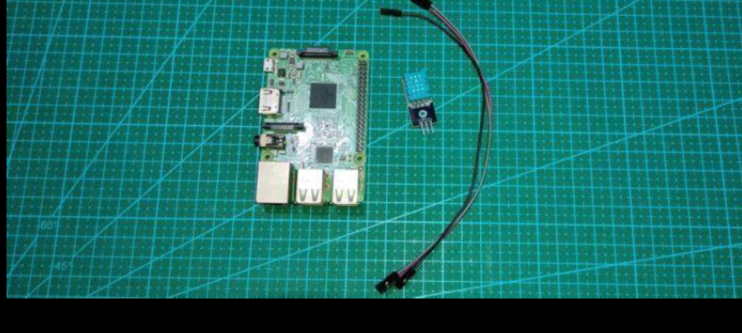

• Raspberry Pi with keyboard and mouse. Or putty terminal.

DHT11 with Raspberry pi Circuit Diagram

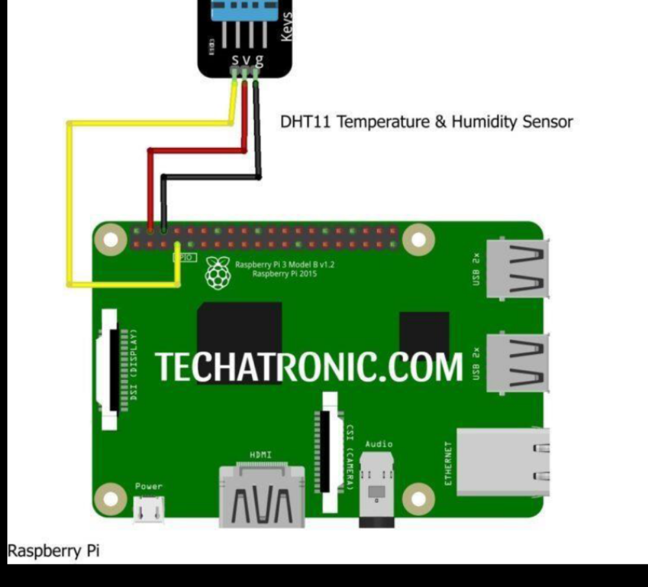

Import Adafruit_DHT
DHT11=Adafruit_DHT.DHT11 # Adafruit_DHT.DHT22 for DHT22 sensor.
While True:
Try:
Temp,humid=Adafruit_DHT.read_retry(DHT11,4) # 4 is ithe GPIO number you can change this to your required need
Print(“TEMP={0:0.1f}°C HUMIDITY={1:0.1f}%”.format(temp,humid)) Except KeyboardInterrupt:
Break

- • The first line as we have said we have imported the library for the DHT11 Sensor to work i.e., Adafruit_DHT. You can use this library with DHt22 also, but you need to change the DHT11 object line.
- • Then we create a DHT object which store the DHT11 sensor configuration details and further in code we use this object name to refer to all working statements.
- • Next we create an infinite while loop within Try and except method to create a

- keyboard interrupt terminating condition i.e., Ctrl+C
- • In next line we read data from the DHT11 sensor and stores it in two variable as two values are being received, one for temperature and other for humidity.

CODING:
!/usr/bin/python
import struct, array, time, io, fcntl
I2C_SLAVE=0x0703
# find with sudo i2cdetect -y 1
HDC1008_ADDR = 0x40
bus=1
fr = io.open("/dev/i2c-"+str(bus), "rb", buffering=0)
fw = io.open("/dev/i2c-"+str(bus), "wb", buffering=0)
# set device address
fcntl.ioctl(fr, I2C_SLAVE, HDC1008_ADDR)
fcntl.ioctl(fw, I2C_SLAVE, HDC1008_ADDR)
time.sleep(0.015) #15ms startup time
s =

